Beyond Coverage: Building Infrastructure for Sustainable Maternal Health Improvements
Why Organizational Readiness Predicts Maternal Health Outcomes: Analysis of 51 U.S. Jurisdictions (2018-2023)
Marshawn Shelton, MPH, PMP, CCMP
Founder, Isosalus
November 2025

Executive Summary
The United States invested billions of dollars to expand Medicaid coverage for maternal health, yet disparities remain. This analysis of 51 jurisdictions shows that simply expanding coverage without addressing the underlying health system infrastructure results in unstable, unsustainable outcomes.
Key Findings:
- National maternal mortality decreased by 45% between 2021 and 2023, from 32.9 to 18.2 deaths per 100,000 live births, following the Medicaid postpartum extension.
- States with a comprehensive operational infrastructure demonstrated outcomes that were 4.7 times more stable than those without similar infrastructure indicators, a finding crucial to success in value-based care.
- Infrastructure indicates steady performance rather than rapid growth: states with high infrastructure levels consistently had low mortality rates (average 20.9 per 100,000), while states with low infrastructure experienced unpredictable, crisis-driven fluctuations (average 39.2 per 100,000).
- Geographic disparities persist: maternal mortality rates differ threefold across states, with Southern states averaging 2-3 times higher mortality than Northeastern states.
Bottom Line:
Policy coverage does not necessarily reflect a state's ability to run its programs effectively. Before adopting value-based care risk, states need to assess and build their infrastructure. The OE-3PI™ Framework identifies gaps in processes (access systems), people (workforce support), and technology (data systems), allowing targeted investments that foster sustainable progress.

The State of Maternal Mortality (2023)

There is National Progress, but it Remains Fragile.
Following the April 2022 Medicaid postpartum coverage extension, national maternal mortality rates declined significantly.
- 2021 (COVID peak): 32.9 deaths per 100,000 live births.
- 2023 (after extension): 18.2 deaths per 100,000 live births
- Overall improvement: 45% reduction
This indicates about 550 fewer maternal deaths annually, a notable decline after years of rising mortality.
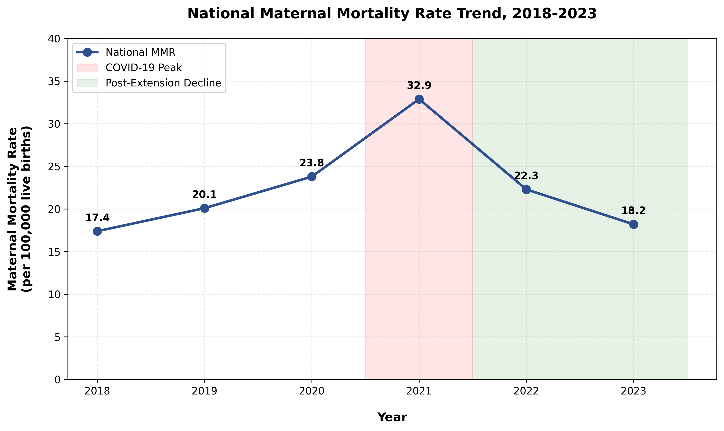
Figure 1. National maternal mortality rate trend, 2018-2023. National maternal mortality declined 45% from the 2021 peak (32.9 per 100,000 live births) to 2023 (18.2 per 100,000), following the April 2022 Medicaid postpartum coverage extension from 60 days to 12 months. The 2021 peak reflects disruptions to prenatal and postpartum care access during the COVID-19 pandemic. Source: CDC WONDER Compressed Mortality Database, 2018-2023. Author's analysis.
However, national averages conceal substantial differences between states, despite all states implementing the same federal policy; outcomes varied by state's infrastructure.

Geographic Disparities: The Infrastructure Gap
Despite the widespread adoption of policies, state maternal mortality rates in 2023 varied from 3.4 to 48.6 per 100,000 births, a staggering 14-fold difference.
Best Performing States (2023).
- Minnesota: 3.4 per 100,000
- Utah: 4,1 per 100.000
- Colorado: 5.2 per 100,000
Worst Performing States (2023).
- Alabama: 48.6 per 100,000
- Tennessee: 47.0 per 100,000
- Georgia: 45.8 per 100,000
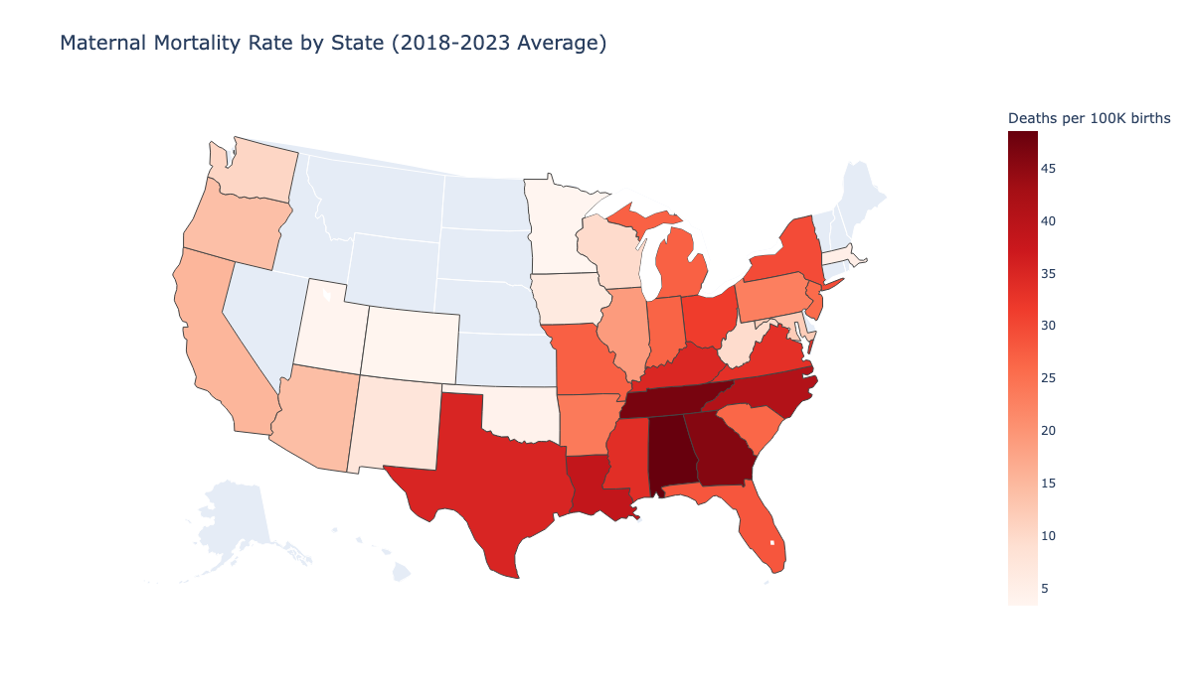
Figure 2. Average state maternal mortality rates, 2018-2023 Geographic visualization of average maternal mortality rates across U.S. states (2018-2023). Darker shading indicates a higher average MMR. States range from 3.4 per 100,000 live births (Minnesota, best) to 48.6 per 100,000 (Alabama, worst), demonstrating persistent regional disparities despite universal federal policy implementation. The North-South divide suggests organizational infrastructure differences beyond policy coverage. Source: CDC WONDER Compressed Mortality Database, 2018-2023. Author's analysis.
The persistent North-South divide suggests that differences in regional operational infrastructure, not just policy coverage, influence outcomes.
Critical Insight:
States with similar demographics and policy environments had vastly different results. The primary distinction was how ready they were to turn policy into action.

Infrastructure Predicts Performance

What Infrastructure Means: The OE-3PI™ Framework

Operational infrastructure consists of three interconnected pillars:
  - Process Pillar: Access Infrastructure
Systems Supporting Care Access
- Examples include: Medicaid expansion, care coordination pathways, referral networks, and transportation support.
- Impact: Creates a foundation for coverage to translate into care
  - People Pillar: Workforce Support
Programs supporting patients and providers
- Examples include: doula programs, community health workers, paid family leave, provider training, and care management.
- Impact: Facilitates human-centered, culturally responsive care delivery
  - Technology Pillar: Data & Learning Systems
Capabilities for measurement and improvement
- Examples include: Maternal mortality review committees (MMRCs), real-time surveillance, quality dashboards, and outcome tracking.
- Impact: Promotes ongoing learning and data-driven adaptation
Infrastructure maturity was assessed across 51 jurisdictions using four indicators aligned with these three pillars: Medicaid expansion status (Process), Medicaid doula coverage (People), paid family leave programs (People), and established MMRC operations (Technology) with over 10 years of experience. Each state was assigned a score from 0 to 4 based on the number of indicators present.

The Evidence: Infrastructure Predicts Outcomes

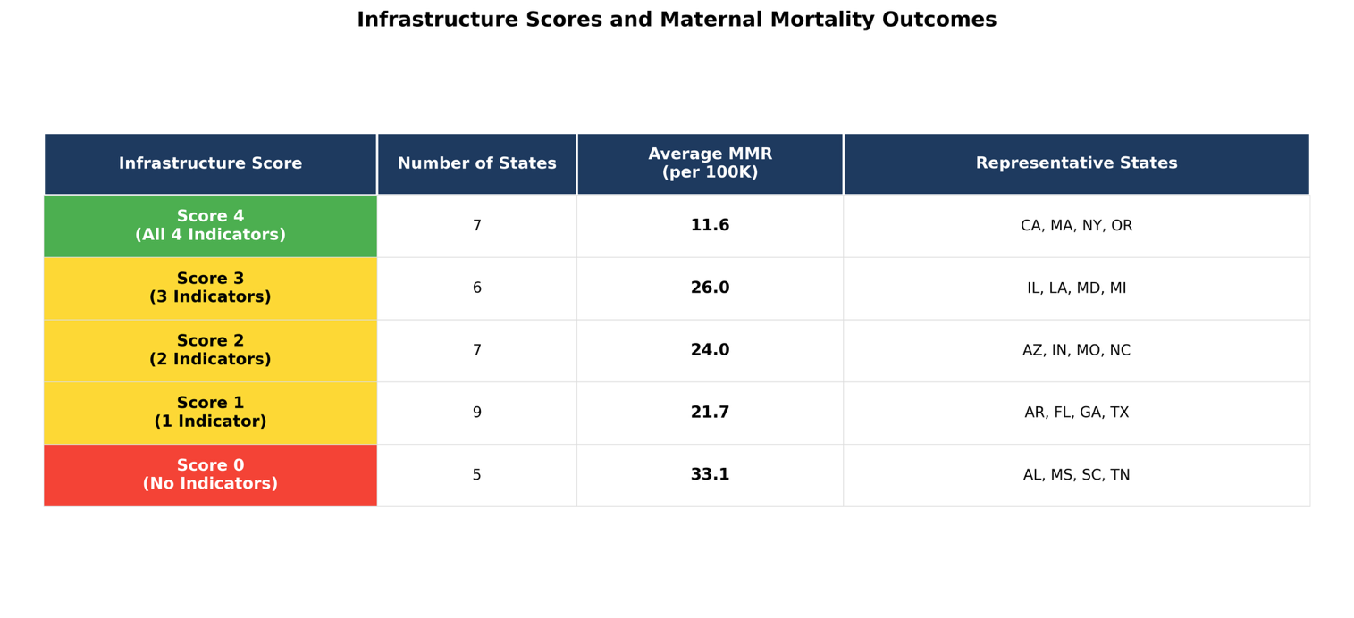
Analysis shows a strong correlation between infrastructure and maternal mortality (r = -0.367, p = 0.033), especially at the extremes.

Figure 3. Infrastructure scores and maternal mortality outcomes by state. Infrastructure score based on the presence of four indicators: (1) Medicaid expansion, (2) Medicaid doula coverage, (3) paid family leave, and (4) an established Maternal Mortality Review Committee with 10+ years of operation. Analysis includes 34 states with sufficient maternal mortality data (2018-2023); 17 states were excluded due to CDC small-count suppression. Source: CDC WONDER Compressed Mortality Database; Kaiser Family Foundation; National Health Law Program; National Partnership for Women & Families; CDC Review to Action Program. Author's analysis.

States with comprehensive infrastructure (Score 4) have a 47% lower baseline mortality rate than states without infrastructure (Score 0).
Exemplar States:
- Massachusetts (Score 4): MMR 15.6, showing consistent excellence
- Oregon (Score 4): MMR 28.3, demonstrating steady performance
- California (Score 4): MMR 20.1, remaining stable despite its size
Infrastructure Gap States:
- Alabama (Score 0): MMR 48.6, with the highest volatility
- Mississippi (Score 0): MMR 33.8, ongoing challenges
- Wyoming (Score 0): MMR 41.2, limited state capacity

Stability as Value in Value-Based Care

Why Stability Matters: The Value-Based Care Imperative
Traditional metrics emphasize improvement rates: "Which states improved the most?" However, value-based care models prioritize consistent, sustainable performance rather than volatile fluctuations. Analysis shows infrastructure predicts stability more strongly than baseline performance (r = -0.554 for volatility vs r = -0.367 for baseline MMR).

MEASURING STABILITY: COEFFICIENT OF VARIATION
Year-to-year volatility was measured using the coefficient of variation (CV), which is the standard deviation relative to the mean, across 2018-2023.
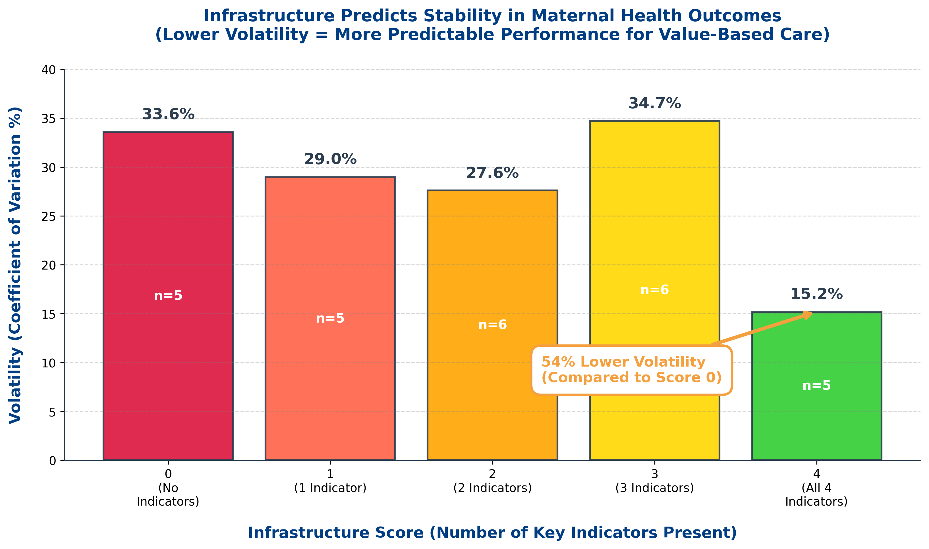
Figure 4. Outcome volatility by infrastructure score, 2018-2023 Four Infrastructure Indicators: (1) Medicaid Expansion, (2) Medicaid Doula Coverage, (3) Paid Family Leave, (4) Established MMRC (10+ years). States scored 0-4 based on number of indicators present. Indicators map to OE-3PI Framework's three pillars: Process, People, Technology. Analysis of 27 states with data spanning both pre-extension (2018-2021) and post-extension (2022-2023) periods. Source: CDC WONDER Compressed Mortality Database. Author's analysis.

Among 27 states with data spanning both time periods, those with comprehensive infrastructure (Score 4, n=5) demonstrated 54% lower volatility (CV=15.2%) compared to states lacking infrastructure (Score 0, n=5, CV=33.6%). Notably, partial infrastructure (Scores 1-3) did not consistently reduce volatility, suggesting a threshold effect where all four infrastructure components must be present to achieve outcome stability. Score 3 states showed the highest volatility (CV=34.7%), driven by extreme variation in Louisiana (52.1%) and Illinois (45.9%).

Real-World Impact: Stability Versus Volatility
Massachusetts (Infrastructure Score 4):
- 2018-2023 MMR range: 2.0 points (14.6 to 16.6 per 100K)
- Coefficient of variation: 9.0%
- Pattern: Maintained low mortality during COVID-19 and policy shifts
- VBC implication: Predictable costs and managed risk
Alabama (Infrastructure Score 0):
- 2018-2023 MMR range: 53.3 points (24.2 to 77.5 per 100K)
- Coefficient of variation: 40.9%
- Pattern: Severe COVID spike (77.5 in 2021), dramatic but unsustainable improvement to 24.2 by 2023
- VBC implication: Uncertain costs and significant financial risk
The difference: Massachusetts remained stable, while Alabama went through a crisis and recovery. Alabama improved by 69%, but remained 50% above Massachusetts' steady baseline.

Implications for Value-Based Care
VBC payment models penalize volatility through:
- Risk adjustment uncertainty (unpredictable baseline)
- Quality metric failures (inconsistent performance)
- Care management costs (crisis-driven utilization)
- Actuarial risk loading (volatility premium)
Infrastructure assessment enables states and health systems to:
- Identify readiness gaps before assuming VBC risk
- Target investment toward stability-enhancing capabilities
- Set realistic performance expectations based on current capacity
- Build sustainable improvement infrastructure, not crisis response

Policy Recommendations

For State Policymakers & Medicaid Directors:

1. Evaluate infrastructure prior to taking on risk.
Before establishing value-based payment arrangements for maternal health:
- Perform a thorough readiness assessment across the Process, People, and Technology pillars.
- Identify key gaps in operational capacity
- Establish baseline stability metrics beyond just current MMR.
- Establish achievable improvement goals based on infrastructure maturity.
Available tool: OE-3PI Framework assessment evaluates organizational readiness for equity-focused implementation.

2. Prioritize Foundation: Medicaid Expansion
Analysis indicates Medicaid expansion states demonstrated:
- 20% greater stability (26.6% CV vs 32.0% CV in non-expansion states)
- Stronger baseline performance (average 28.7 vs. 35.4 per 100,000)
- Better platform for additional programs (doula, CHW, navigation)
Access is essential for workforce and technology investments to produce returns. Coverage builds the patient panel; infrastructure facilitates effective care delivery.

3. Build Workforce Support Systems
States with People pillar investments showed enhanced stability:
Doula Programs: 21 states now include doula services in Medicaid coverage
- Evidence: Lowers cesarean deliveries, preterm births, and encourages breastfeeding.
- Implementation: Medicaid reimbursement, certification pathways, provider network expansion
- Investment: $1,000-$2,500 per birth; ROI from fewer complications.
Paid Family Leave: 14 jurisdictions have enacted programs.
- Evidence: Promotes postpartum recovery, supports breastfeeding, and lowers maternal stress
- Implementation: State insurance fund or employer mandate.
- Investment: 0.2-0.9% payroll tax; ROI via workforce retention and infant health.
Community Health Workers: Emerging Best Practices
- Evidence: Enhances adherence to prenatal care, links to services, and addresses social determinants.
- Implementation: Medicaid reimbursement, CHW certification, and care team integration
- Investment: $50,000-$70,000 per FTE; ROI from reducing emergency department visits

4. Strengthen Data & Learning Systems
All 51 jurisdictions have Maternal Mortality Review Committees (MMRCs), but maturity varies:
Established MMRCs (10+ years): 18 states
- Characteristics: Systematic case review, actionable recommendations, policy alignment
- Outcomes: Reduced initial MMR, recorded improvement efforts
Developing MMRCs (1-4 years): 16 states
- Characteristics: Building processes, data quality problems, and limited follow-through.
- Opportunity: Speed up maturity with CDC technical assistance and peer learning.
Advancement in the technology pillar requires:
- Real-time surveillance (not just retrospective review)
- EHR integration for risk assessment
- Quality dashboards to ensure provider accountability
- Data linkage between Medicaid, vital statistics, and hospitals.
Investment: $500K-$2M for comprehensive data infrastructure; ROI through targeted interventions and waste reduction.

5. Plan for Long-Term Investment
Key findings on infrastructure and enhancements:
- Infrastructure indicates sustained performance, not quick improvement.
- States with weak infrastructure showed inconsistent "improvement" that was driven by regression to the mean rather than capacity building.
- Sustainable change requires a 5 to 10-year investment horizon.
Recommended approach:
- Year 1-2: Assess gaps, build foundation (access infrastructure)
- Year 3-4: Scale workforce programs (doula, CHW, care management)
- Year 5+: Mature technology systems, demonstrate sustained excellence
VBC readiness timeline: 3-5 years from infrastructure investment to stable, excellent outcomes suitable for risk-bearing arrangements.

Methodology & Contact

Study Design

This study uses a cross-sectional observational design to examine the relationship between state-level operational infrastructure and maternal mortality outcomes across 51 U.S. jurisdictions (50 states plus the District of Columbia) over a 6-year period (2018-2023).

Data Sources
Primary Outcome Data:
- CDC WONDER Compressed Mortality Database (2018-2023)
  - ICD-10 codes: O00-O99 (pregnancy, childbirth, and puerperium-related deaths)
  - Deaths that happen during pregnancy or within 42 days after pregnancy ends
  - State-level death and live birth data were extracted in November 2025.
Infrastructure Indicator Data:
- Medicaid Expansion Status: Kaiser Family Foundation State Health Facts
- Medicaid Doula Coverage: National Health Law Program Doula Coverage Tracker (2025)
- Paid Family Leave Programs: National Partnership for Women & Families State Policy Database
- Maternal Mortality Review Committees: CDC Review-to-Action Program

Statistical Analysis
Descriptive Analysis:
- States categorized according to their Infrastructure Score (0-4)
- MMR computed for each state-year data point
- Mean, median, range, and coefficient of variation calculated for each infrastructure group.
Correlation Analysis:
- Pearson correlation coefficients calculated between infrastructure score and average MMR (2018-2023), as well as the coefficient of variation (stability measure).
- Statistical significance evaluated at α = 0.05
Sample Size: 146 state-year observations with valid MMR data; 34 states with a complete 6-year time series.

Limitations
- CDC's small-count suppression impacts data completeness in less populous states.
- State-level analysis might hide variation within states
- Infrastructure scoring includes four indicators but does not represent the entire organizational capacity.
- Policy implementation effects take 3-5 years to fully materialize.
- A cross-sectional design restricts causal inference.

About the Author
Marshawn Shelton, MPH, PMP, CCMP, is the founder of Isosalus, a company specializing in health equity technology. The company focuses on creating platforms for evaluating and building infrastructure for health systems and policymakers.
Having led healthcare transformation initiatives at major health systems such as Grady Health System, Penn Medicine, and Piedmont Healthcare, Marshawn offers frontline operational expertise to develop evidence-based platforms.
Education:
- Master of Public Health (MPH), Morehouse School of Medicine.
- Bachelor of Science (B.S.) in Management, Virginia State University.
Certifications:
- Project Management Professional (PMP)
- Certified Change Management Professional (CCMP)

Contact
Marshawn Shelton, MPH, PMP, CCMP
Founder, Isosalus
LinkedIn: linkedin.com/in/marshawnshelton
For media inquiries, speaking engagements, or platform demonstration requests, contact via LinkedIn.

© 2025 Marshawn Shelton / Isosalus. All rights reserved.
The OE-3PI™ Framework and related materials are proprietary. This policy brief can be shared for educational and policy reasons with proper attribution.
Recommended Citation:
Shelton, M. (2025). Beyond Coverage: Building Infrastructure for Sustainable Maternal Health Improvement. Isosalus Policy Brief.

